THE UNIVERSITY OF BAMENDA

DEPARTMENT OF COMPUTER ENGINEERING
THE COLLEGE OF
TECHNOLOGY

WATAREPORT – COMMUNITY WATER SERVICE DISRUPTION REPORTING SYSTEM FOR BAMENDA, CAMEROON

A Project Submitted to the Department of Computer Engineering in the
College of Technology of the University of Bamenda in Partial Fulfillment of the Requirements for the Award of a Bachelor of Technology in Computer Networks and System Maintenance

BY:
Name
TEYIM YANICK NJIGMESHI
Registration Number:
UBA23PH049
SUPERVISOR:
Dr. ATANGANA OTELE
2025/2026

ABSTRACT
Access to safe and clean water remains a major challenge in many local communities in Bamenda, Cameroon. This project presents the design and implementation of a web-based water quality monitoring system aimed at supporting local communities, councils, and non-governmental organizations (NGOs) in monitoring and managing water quality. The system allows community members to manually submit water quality observations and test results through a web application, creating a centralized and accessible platform for water quality data collection.
The application is developed using PHP (Laravel), HTML, CSS, and JavaScript, and provides features such as user authentication, water source registration, data visualization, and status reporting. Councils can verify the condition of water sources within their jurisdiction, while NGOs can use the collected data to provide recommendations for improving water quality. The system is designed to operate effectively under intermediate internet conditions common in Bamenda, with future support for sensor-based data integration beyond the scope of this project.
The proposed solution enhances community participation, improves access to water quality information, and supports informed decision-making to promote public health and environmental sustainability.

DEDICATION
This project is dedicated to my parents, whose continuous support, guidance, and encouragement have been a source of motivation throughout my academic journey.

ACKNOWLEDGEMENT
I sincerely express my gratitude to Central University Bamenda and all its staff for the knowledge and academic foundation provided throughout my studies. I also extend my sincere appreciation to my project supervisor for his guidance, encouragement, and valuable advice, which greatly contributed to the successful completion of this project.
My profound gratitude goes to my parents and family members for their moral, emotional, and financial support throughout my academic journey. I also thank my friends and classmates for their encouragement and assistance in one way or another. Above all, I thank the Almighty God for the gift of life, strength, and wisdom throughout the execution of this project.

TABLE OF CONTENT

ABSTRACT 2
DEDICATION 3
ACKNOWLEDGEMENT 4
CHAPTER ONE 8
INTRODUCTION 8
1.1 Context (Background of the Study) 8
1.2 Problem Statement 9
1.3 Research Questions 9
1.3.1 General Research Question 9
1.3.2 Specific Research Questions 9
1.4 Objectives of the Study 10
1.4.1 General Objective 10
1.4.2 Specific Objectives 10
1.5 Justification and Motivation 10
1.6 Significance of the Study 10
1.7 Scope 11
1.8 Limitations 11
1.9 Delimitations 12
CHAPTER TWO 13
LITERATURE REVIEW 13
2.1 Introduction 13
2.2 Water Service Disruption Management 13
2.3 Web-Based Reporting Systems for Infrastructure Issues 14
2.4 Community-Based Reporting Approaches 14
2.5 Role of Water Companies and Service Providers 15
2.6 Geographic Information Systems (GIS) and Live Location Mapping 15
2.7 Gaps in Existing Studies 16
2.8 Summary of Literature Review 17
CHAPTER THREE 18
RESEARCH METHODOLOGY AND SYSTEM DESIGN 18
3.0 Introduction 18
3.1 Justification for Design Science Approach 18
3.2 Requirements Gathering 19
3.2.1 Data Collection Methods 19
3.2.2 Functional Requirements 19
3.2.3 Non-Functional Requirements 19
3.3 System Architecture 20
3.3.1 Architectural Overview 20
3.3.2 Presentation Tier (Frontend) 21
3.3.3 Application Tier (Backend) 21
3.3.4 Data Tier (Database) 22
3.4 Database Design 23
3.4.1 Table Structures 23
3.4.2 Relationships and Constraints 24
3.4.3 Indexing Strategy 25
3.5 User Interface Design 25
3.5.1 Design Principles 25
3.5.2 Color Scheme 25
3.5.3 Screen Designs and Wireframes 26
3.6 Development Methodology 30
3.6.1 Selection of Waterfall Methodology 30
3.6.2 Phases of the Waterfall Model 30
3.8 Development Tools and Environment 31
3.8.1 Hardware Environment 31
3.8.2 Software Development Tools 32
3.8.3 Technology Stack Summary 32
3.9 Testing Strategy 34
3.9.1 Unit Testing 34
3.9.2 Integration Testing 34
3.9.3 System Testing 34
3.9.4 User Acceptance Testing 34
3.10 Ethical Considerations 35
3.10.1 Data Privacy and Protection 35
3.10.2 Informed Consent 36
3.10.3 Data Accuracy and Transparency 36
3.10.4 System Use Disclaimer 36
3.11 System Diagrams 36
3.11.1 Use Case Diagram 36
3.11.2 Class Diagram 37
3.11.3 Entity Relationship Diagram 38
3.11.4 Activity Diagram (Report Submission Flow) 39
3.11.5 Sequence Diagram (Report Status Update) 40
3.12 Summary 41
References 43

CHAPTER ONE

INTRODUCTION

1.1 Context (Background of the Study)
Access to reliable water supply is fundamental to human health, daily living, and economic activity. In many parts of Cameroon, particularly in the North West Region and the city of Bamenda, residents depend on pipe-borne water systems managed by water companies. These systems deliver water to households, businesses, and public facilities through an extensive network of pipes, taps, and distribution points.
However, water service disruptions are a daily reality for many residents in Bamenda. These disruptions take multiple forms: burst pipes that leak water for days without repair, sudden water cuts with no explanation, and service suspensions due to unpaid bills. When a pipe bursts, water is wasted, roads are damaged, and nearby households lose access to supply. When water is cut without warning, residents do not know whether the cause is a technical fault, planned maintenance, or a billing issue. This confusion leads to frustration, wasted time, and delayed resolution.
Currently, there is no centralized or functional system for residents to report these disruptions directly to water companies. In some cases, residents must call phone numbers that are rarely answered. In other cases, they must travel to water company offices to complain. Some residents simply wait, hoping the problem will fix itself. Water companies, on the other hand, lack a structured way to receive, track, and respond to citizen reports. Repair teams may not know where bursts are located. Bill collectors have no way to communicate with customers about overdue payments before cutting water supply.
With the growing availability of internet services and the widespread use of mobile phones in Bamenda, a web-based platform offers a practical solution to this challenge. Such a platform can provide a centralized space where community members report water service disruptions using live location mapping, and water company staff can view, manage, and respond to these reports in real time. This project focuses on designing and implementing a web-based water service disruption reporting system tailored to the needs of local communities and water companies in Bamenda, Cameroon.

1.2 Problem Statement
Despite the importance of reliable water supply, water service disruption management in Bamenda remains inadequate, unstructured, and fragmented. There is no centralized web-based platform that allows community members to report disruptions such as burst pipes, unexplained water cuts, or bill-related suspensions directly to water companies using live location mapping.
As a result, residents face multiple challenges. Burst pipes may leak for days or weeks because no one knows how to report them effectively. When water is cut, residents often cannot determine the cause—whether it is a technical fault, planned maintenance, or an unpaid bill. Those whose water is suspended due to unpaid bills may not receive any warning or clear information on how to restore service. Water companies struggle to prioritize repairs because they lack real-time data on the location and severity of disruptions. Plumbers and repair teams waste time searching for reported problems due to inaccurate or missing location information. Bill collectors have no efficient way to notify customers before service suspension.
The key problem addressed by this study is the lack of a localized, affordable, web-based system that enables community members to report water service disruptions with live location data and enables water companies to receive, manage, and respond to these reports efficiently.

1.3 Research Questions

1.3.1 General Research Question
How can a web-based application be used to improve the reporting and management of water service disruptions in local communities in Bamenda?

1.3.2 Specific Research Questions
- How can community members report water service disruptions (burst pipes, no water flow, bill-related suspensions) through a web platform with live location capture?
- How can water companies (plumbers, bill collectors, customer service staff) receive, manage, and respond to reported disruptions using a centralized dashboard?
- How can the system provide residents with transparency and status updates on their reported issues?

1.4 Objectives of the Study

1.4.1 General Objective
To design and implement a web-based water service disruption reporting system that supports community members and water companies in managing water service disruptions in Bamenda, Cameroon.

1.4.2 Specific Objectives
- To examine existing water disruption reporting practices in local communities in Bamenda.
- To design a user-friendly web application for manual submission of water disruption reports with automatic live location capture.
- To develop a centralized database for storing and managing water disruption records, including report status and resolution tracking.

1.5 Justification and Motivation
This project is motivated by the daily struggles of Bamenda residents who face water disruptions without any effective means of reporting them. It is also motivated by the challenges water companies face in receiving accurate, location-based information from the communities they serve.
Unlike expensive sensor-based systems that are unaffordable for local contexts, this project uses basic web and mobile technologies that are already accessible to most residents. By building a simple, map-based reporting platform, this project aims to bridge the communication gap between communities and water companies, leading to faster response times, reduced water loss from burst pipes, and improved transparency around water service interruptions—including those related to bill payments.

1.6 Significance of the Study
The system will provide the following benefits:
Stakeholder | Benefit
Community Members | A simple way to report water disruptions with automatic location capture; ability to track the status of their reports; transparency about whether water cuts are due to technical issues or billing problems
Water Companies (Plumbers, Bill Collectors, Customer Service) | A centralized dashboard to receive and manage reports; accurate location data to guide repair teams; ability to communicate with residents about bill-related suspensions
Local Government Regulators | Data on recurring disruptions to inform infrastructure investment decisions

1.7 Scope
This project focuses on the development of a web-based water service disruption reporting system for Bamenda, Cameroon. The system allows community members to submit reports manually through a web application with live location mapping. Water company staff can view, update, and resolve reports through a secure dashboard. The scope includes the following disruption types:
- Burst pipes
- No water flow (unexplained cuts)
- Water suspension due to unpaid bills
- Other water service disruptions
The project excludes real-time sensor integration, automated water quality testing, and mobile SMS-based reporting.

1.8 Limitations
One of the major limitations of this study is its dependence on internet connectivity, which may be inconsistent in some parts of Bamenda and surrounding communities, thereby affecting timely access to the web application. In addition, the system relies on manually submitted data from community members, which may vary in accuracy due to differences in users' knowledge, honesty, or ability to correctly identify disruption types. Live location capture depends on the availability of GPS on the user's device, which may not be present on all mobile phones. Furthermore, the system does not automatically verify whether a reported burst pipe or water cut is genuine, relying instead on water company staff to validate reports. These limitations may influence the completeness and reliability of the data collected; however, the system is designed to mitigate these challenges through structured data entry forms and verification by water company staff.

1.9 Delimitations
This study is deliberately limited in scope to Bamenda and nearby local communities in the North West Region of Cameroon in order to ensure relevance and manageability at the Bachelor level. The project focuses exclusively on the development of a web-based water service disruption reporting application using manual data entry with live location mapping. It does not include the design or implementation of physical sensors, automated water quality testing, or integration with water company billing systems. The system addresses reporting and tracking of water service disruptions rather than direct repair of infrastructure or water bill payment processing. These delimitations allow the study to concentrate on addressing local communication challenges between communities and water companies using web technologies while providing a foundation for future expansion.

CHAPTER TWO

LITERATURE REVIEW

2.1 Introduction
This chapter reviews existing literature related to water service disruption management, web-based reporting systems, community-driven data collection approaches, geographic information systems (GIS) for infrastructure reporting, and the role of water companies in customer communication. The review establishes the theoretical and practical background of the study and highlights gaps in existing research that justify the need for a localized, web-based water service disruption reporting system for communities and water companies in Bamenda, Cameroon.

2.2 Water Service Disruption Management
Water service disruption refers to any interruption in the delivery of piped water to households, businesses, or public facilities. According to the World Health Organization (2024), reliable water supply is essential for public health, hygiene, and economic activity. Disruptions can take multiple forms, including infrastructure failures (burst pipes), operational issues (maintenance), and administrative actions (service suspension due to unpaid bills).
Burst Pipes: Burst pipes are among the most common causes of water service disruption in urban and semi-urban areas. A study by Tchoupo et al. (2022) in Douala, Cameroon, found that aging infrastructure, poor maintenance, and road construction activities were the primary causes of pipe bursts. The study also noted that burst pipes often go unreported for days or weeks because residents lack an effective reporting mechanism, leading to significant water loss and property damage.
Unexplained Water Cuts: In many Cameroonian cities, residents frequently experience sudden water cuts without any notification or explanation. Nkeng and Elambo (2021) surveyed households in Bamenda and found that over 60% of respondents had experienced at least three unexplained water cuts in the preceding month. The lack of communication from water companies leaves residents confused about whether the disruption is due to a technical fault, planned maintenance, or a billing issue.
Bill-Related Service Suspension: Water companies commonly suspend service when customers fail to pay their bills on time. However, research by Mbaku (2023) in the North West Region of Cameroon revealed that many residents receive no prior warning before their water is cut. Furthermore, residents often do not know how to resolve the suspension quickly or who to contact. This lack of transparency creates frustration and mistrust between water companies and the communities they serve.

2.3 Web-Based Reporting Systems for Infrastructure Issues
Web-based information systems have increasingly been adopted for reporting public infrastructure problems such as potholes, broken streetlights, and water leaks. These systems allow citizens to report issues through an internet-enabled platform, which is then stored in a centralized database and made accessible to relevant authorities.
Global Examples: In the United States, platforms like SeeClickFix and 311 services enable residents to report non-emergency infrastructure issues directly to local governments (Johnson & Martinez, 2021). In Kenya, the MajiVoice platform allows citizens to report water service problems to utility companies via web and mobile interfaces (Otieno & Wanjiru, 2022). These platforms have demonstrated improved response times and increased citizen satisfaction.
Applicability to Cameroon: Despite the success of such platforms elsewhere, similar systems are largely absent in Cameroon. A review by Fombu and Ndeh (2023) found that while several pilot projects have been attempted in Yaoundé and Douala, none have been sustained or scaled to cities like Bamenda. The authors attributed this to lack of funding, poor internet infrastructure, and absence of local technical expertise.

2.4 Community-Based Reporting Approaches
Community-based reporting involves the active participation of local residents in identifying and reporting service delivery problems. Several studies emphasize that involving communities in reporting increases coverage, promotes civic engagement, and encourages a sense of ownership over local infrastructure (Chambers, 2018; Cornwall & Gaventa, 2021).
Citizen Reporting in Water Services: In the water sector, community-based reporting has been used to identify leaks, burst pipes, and illegal connections. A study by Akinyemi and Adebayo (2022) in Lagos, Nigeria, found that community members who were given a simple mobile reporting tool reported 45% more water infrastructure faults than areas relying on official inspections alone.
Challenges: However, effective community-based reporting requires simple, user-friendly systems to ensure participation and data reliability. Nwachukwu et al. (2023) noted that many reporting systems fail because they assume high levels of literacy, smartphone access, and internet connectivity, which are not always available in African communities. Therefore, systems designed for contexts like Bamenda must be lightweight, mobile-friendly, and accessible to users with basic phones.

2.5 Role of Water Companies and Service Providers
Water companies in Cameroon, including CAMWATER and various municipal utilities, are responsible for managing water distribution, maintaining infrastructure, collecting bills, and responding to customer complaints. However, research indicates that these companies face significant challenges in customer communication and service disruption management (Ngwa & Ako, 2022).
Customer Communication Gaps: A survey by Ewane and Fonyuy (2023) of water company staff in the North West Region found that most customer complaints are still received by phone or in-person visits. No centralized digital system exists for logging, tracking, or responding to reports. As a result, complaints are often lost, forgotten, or delayed.
Bill Collection and Suspension Processes: Bill collection is a critical function of water companies, yet it is often disconnected from customer communication systems. Tchinda and Nana (2021) found that water companies in Cameroon typically send paper bills or SMS reminders, but these messages may not reach customers due to incorrect contact information or network issues. When bills remain unpaid, service is suspended—often without final warning—leaving customers confused and frustrated.
Plumbers and Repair Teams: Repair teams responsible for fixing burst pipes and restoring water flow often operate without accurate location data. A study by Mbah and Ndum (2022) revealed that plumbers in Bamenda waste an average of 2-3 hours per day searching for reported burst pipes because residents provide vague or incorrect location descriptions. This delay prolongs water loss and extends the duration of service disruption.

2.6 Geographic Information Systems (GIS) and Live Location Mapping
Geographic Information Systems (GIS) and live location mapping technologies have revolutionized infrastructure reporting by enabling precise location capture and visualization. When citizens report an issue, their device's GPS can automatically capture latitude and longitude coordinates, eliminating the need for vague verbal descriptions (Goodchild, 2018).
Map-Based Reporting: Platforms such as Ushahidi (originally developed in Kenya) and Mapillary have demonstrated the power of map-based citizen reporting. Users can pin issues on a map, add photos and descriptions, and view previously reported issues in their area (Okolloh, 2019).
Integration with Water Services: In the water sector, location mapping has been used to track leak reports, identify recurring burst pipe locations, and guide repair teams. A study by Mwangi and Karanja (2022) in Nairobi, Kenya, implemented a map-based water fault reporting system and reduced average response time from 72 hours to 24 hours. The key success factor was automatic location capture, which eliminated the need for users to describe where the problem was located.
Feasibility for Bamenda: With the widespread availability of smartphones and GPS in Bamenda, live location mapping is technically feasible. However, researchers caution that systems should include a manual location adjustment feature, as GPS accuracy can vary, and some users may prefer to correct the pin location (Nformi & Che, 2023).

2.7 Gaps in Existing Studies
Although several studies have explored water service disruption reporting systems, significant gaps remain.
Gap | Description
No localized system for Bamenda | Most existing research focuses on other African cities (Nairobi, Lagos, Cape Town). No study has documented the design, implementation, or evaluation of a water disruption reporting system specifically for Bamenda, Cameroon.
Bill suspension not addressed | Existing reporting systems focus on infrastructure faults (burst pipes, leaks) but rarely include bill-related service suspension as a reportable issue. This is a major gap because many water cuts in Cameroon are bill-related.
Integration of multiple disruption types | Most systems address only one type of disruption (e.g., burst pipes only). No system found in the literature comprehensively addresses burst pipes, unexplained cuts, and bill-related suspensions in a single platform.
Water company dashboard lacking | Many citizen reporting systems collect data but do not provide a functional dashboard for service providers to manage and respond to reports. This limits the system's usefulness for water companies.
Limited attention to local technology constraints | Many proposed systems assume high-speed internet and latest smartphones. Few studies address the reality of low-bandwidth connections and basic devices common in Bamenda.

2.8 Summary of Literature Review
The literature reviewed demonstrates that water service disruptions—including burst pipes, unexplained cuts, and bill-related suspensions—are significant problems in Cameroonian cities, particularly Bamenda. While web-based citizen reporting systems have been successfully implemented elsewhere for infrastructure issues, no such system exists for water service disruptions in Bamenda.
The review also highlights the importance of community participation, live location mapping, and water company dashboards for effective disruption management. Furthermore, it identifies a critical gap: existing systems and studies rarely address bill-related service suspension as a reportable issue.
This study seeks to address these gaps by designing and implementing WataReport, a web-based water service disruption reporting system that:
- Allows community members to report burst pipes, unexplained water cuts, and bill-related suspensions
- Captures live location data automatically
- Provides a dashboard for water company staff (plumbers, bill collectors, customer service)
- Is optimized for the technological conditions (low bandwidth, basic smartphones) of Bamenda, Cameroon

CHAPTER THREE

RESEARCH METHODOLOGY AND SYSTEM DESIGN

3.0 Introduction
This chapter presents the research methodology and system design for WataReport, a web-based water service disruption reporting system for Bamenda, Cameroon. It describes the research approach, requirements gathering methods, system architecture, database design, user interface design, development methodology, tools, testing strategy, deployment plan, and ethical considerations, translating stakeholder requirements into a concrete technical blueprint ready for implementation.
The study adopts a Design Science Research Methodology (DSRM) , which focuses on creating and evaluating technological artifacts to solve real-world problems. This approach was selected because the primary outcome is a functioning web application addressing inadequate water service disruption reporting in Bamenda. DSRM consists of five sequential phases: problem identification and motivation from Chapter One, definition of solution objectives based on stakeholder needs, design and development as the focus of this chapter, demonstration through implementation, and evaluation through testing and user feedback. This methodology was chosen because it is problem-oriented, emphasizes rigorous evaluation, is widely accepted in computer science research, and provides clear structure appropriate for a bachelor's degree project.

3.1 Justification for Design Science Approach
Alternative research methodologies were considered but found less suitable for this project. A pure survey methodology would describe existing conditions but would not produce a solution to improve them. An experimental methodology would test hypotheses under controlled conditions but would not address the specific contextual needs of Bamenda residents who face water disruptions daily. A case study approach would provide in-depth understanding of a single situation but would not result in a transferable artifact. The design science approach was therefore selected because it combines understanding of the problem domain with the creation of a practical solution, which aligns perfectly with the project's objectives of designing and implementing a functional web-based water service disruption reporting system.

3.2 Requirements Gathering

3.2.1 Data Collection Methods
Requirements were gathered through three complementary methods. Document analysis of water company reports, ministry publications, and prior studies on water service disruptions in Cameroon revealed that no centralized digital platform exists for residents to report burst pipes, water cuts, or bill-related suspensions, confirming the need for WataReport. Stakeholder analysis identified primary actors including community members, plumbers, bill collectors, customer service staff, and administrators, as well as secondary actors such as water company managers and local government regulators, with each actor's goals and pain points documented to derive functional requirements. Contextual inquiry revealed that community members currently report disruptions through phone calls, WhatsApp messages, or visits to water company offices, but these methods are inefficient, lack tracking, and often result in no response, confirming the need for a structured digital platform.

3.2.2 Functional Requirements
Based on the requirements gathering activities, the following functional requirements were defined. The system must provide an interactive map showing all reported water service disruptions in Bamenda with color-coded pins indicating report status. Users must be able to click on any pin to view detailed information about that disruption including type, description, photo, time reported, and current status. Community members must be able to submit disruption reports through a simple mobile-friendly form that automatically captures their GPS location. Community members must be able to select disruption type from a dropdown including Burst Pipe, No Water Flow (Unexplained), Water Suspension (Bill Related), and Other. Water company staff (plumbers, bill collectors, customer service) must be able to log in to a secure dashboard to view all reports, update report status, assign repair teams, and add internal notes. Administrators must be able to manage user accounts, view all reports, and export report data for analysis. All users must be able to view dashboard statistics showing total reports, pending reports, resolved reports, and average resolution time.

3.2.3 Non-Functional Requirements
Non-functional requirements define quality attributes of the system. For performance, the page load time must be under three seconds on a 3G network connection, the map must load within five seconds, the API must respond within five hundred milliseconds, and the system must support fifty concurrent users. For usability, the system must be fully functional on smartphones with screens as small as 320 pixels, must work acceptably on low-bandwidth connections through optimized images and minimal JavaScript, and must follow accessibility guidelines with touch targets of at least 44 by 44 pixels. For security, all passwords must be hashed using bcrypt, all production traffic must be encrypted using HTTPS, all user inputs must be validated and sanitized to prevent SQL injection and XSS attacks, and API endpoints must have rate limiting to prevent abuse. For reliability, the system must maintain ninety-nine percent uptime during demonstration hours and have daily automated database backups.

3.3 System Architecture

3.3.1 Architectural Overview
WataReport follows a three-tier client-server architecture consisting of a presentation tier, an application tier, and a data tier. This architectural pattern was selected because it separates concerns, improves maintainability, allows each tier to be scaled independently, and is widely supported by web hosting services. The separation between frontend and backend also enables future mobile application development that could reuse the same API.
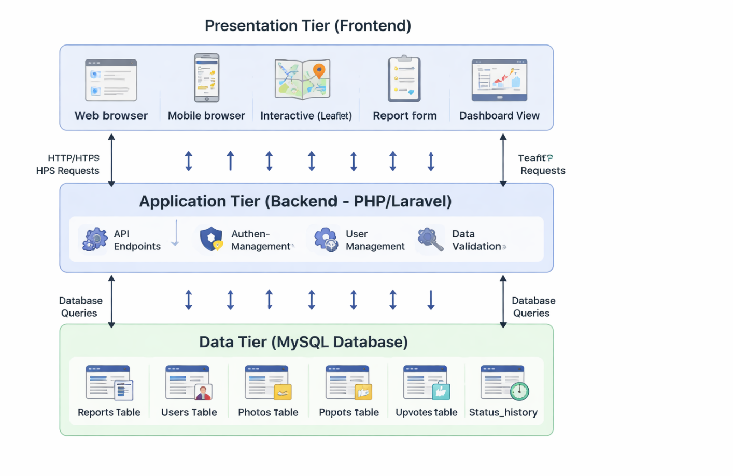
Figure 3.1: Three-Tier System Architecture Diagram

3.3.2 Presentation Tier (Frontend)
The presentation tier is implemented using standard HTML, CSS, and vanilla JavaScript, chosen for their lightweight nature, compatibility with older devices, and suitability for low-bandwidth connections in Bamenda. HTML provides the page structure, CSS handles responsive styling and color-coded status indicators, while JavaScript enables dynamic features such as fetching data from the API, updating the map, and submitting forms without page reloads. Key supporting libraries include Leaflet.js for interactive mapping with OpenStreetMap tiles, the native Fetch API for HTTP requests to the backend, Chart.js for dashboard visualizations showing report trends over time, and Tailwind CSS for accelerated responsive styling. This stack requires no build tools, remains maintainable, and deploys easily on standard web hosting.

3.3.3 Application Tier (Backend)
The application tier handles business logic, authentication, data validation, and API request processing using PHP version 8.1 with the Laravel framework. Laravel was chosen for its robust features including Eloquent ORM for secure database interactions, built-in authentication for session and token management, validation rules for data integrity, middleware for security filtering, and API resources for consistent JSON responses. The backend exposes a RESTful API organized by resource type. Authentication endpoints manage user registration, login, and logout for water company staff and administrators. Reports endpoints support creating new reports (public), retrieving all reports with filtering, retrieving single report details, and updating report status (restricted to water company staff). Dashboard endpoints provide statistics including total reports by status, average resolution time, and reports by disruption type. Photo endpoints handle image upload and retrieval. Export endpoints, restricted to administrators, allow CSV export of all report data. This RESTful design follows standard HTTP conventions, is stateless for scalability, and is widely documented.

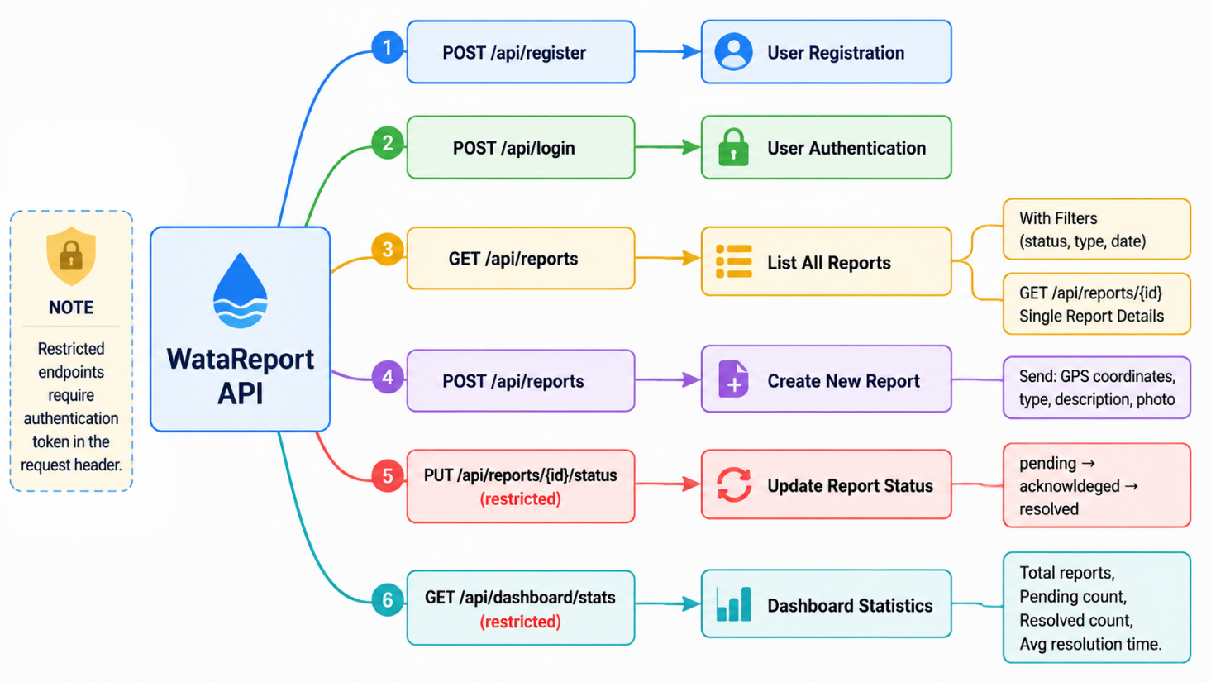
Figure 3.2: API Endpoint Structure Diagram

3.3.4 Data Tier (Database)
The data tier is implemented using MySQL version 8.0, which runs locally through the XAMPP server environment during development. XAMPP was chosen as the development server because it provides a complete, ready-to-use web server package that includes Apache, MySQL, PHP, and phpMyAdmin, allowing the database to be easily managed through a graphical interface. MySQL itself is a reliable open-source relational database management system selected for its wide availability on hosting platforms, strong performance for read-heavy workloads typical of web applications, full ACID transaction support for data integrity, and seamless integration with the Laravel framework through Eloquent ORM. The database schema applies key design principles including normalization to third normal form for reduced data redundancy, referential integrity through foreign key constraints, strategic indexing on frequently queried columns such as status, created_at, and location coordinates for fast response times, and audit fields such as created_at and updated_at timestamps on all tables for tracking data changes.
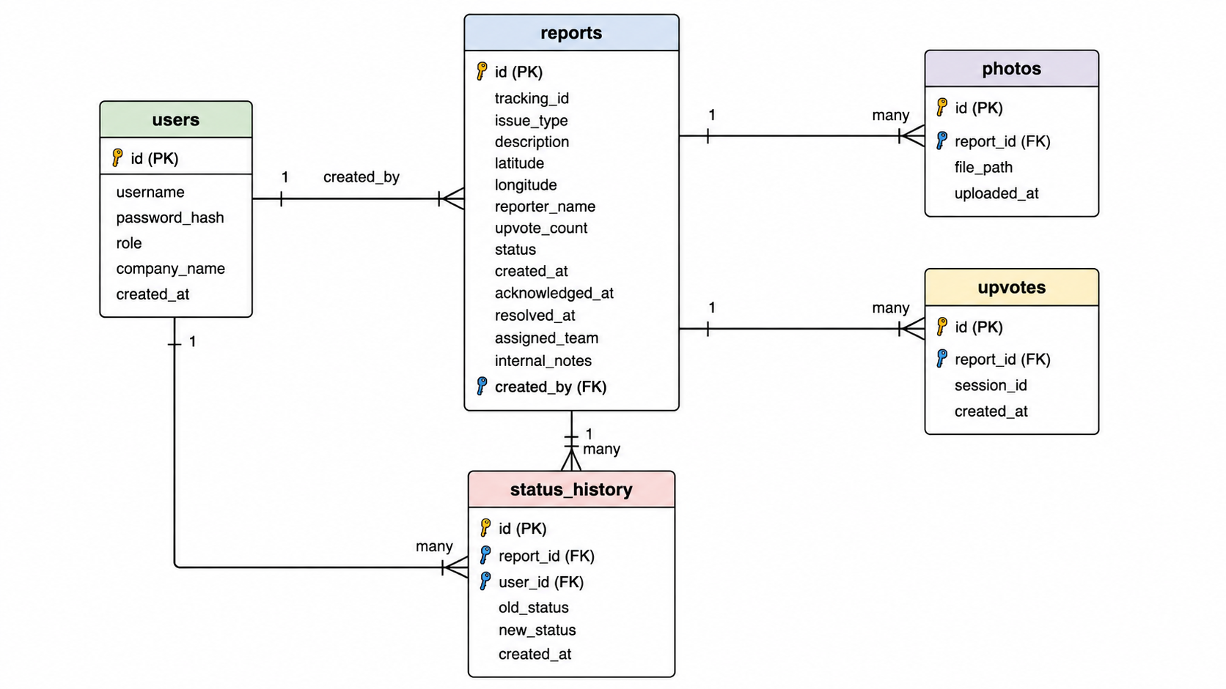

Figure 3.3: Entity-Relationship Diagram

3.4 Database Design

3.4.1 Table Structures
The database comprises five core tables that support all system functionalities.
The users table stores authentication credentials and role assignments for water company staff and administrators. Fields include id as primary key, username for login credentials, password_hash for secure bcrypt storage, role as enum with values 'water_company' and 'admin', company_name for identifying which water company the user belongs to, and created_at and updated_at timestamp fields for audit tracking.
The reports table is the central entity storing all water service disruption reports submitted by community members. Fields include id as primary key, tracking_id as unique user-facing identifier formatted as WB-YYYYMMDD-XXXX, issue_type as enum with values 'burst_pipe', 'no_water_unexplained', 'water_suspension_bill', 'other', description as text field for user-provided details, latitude and longitude as decimal fields for GPS coordinates (precision 10,8 and 11,8 respectively), address as optional varchar for reverse-geocoded location, reporter_name as optional varchar for users who choose not to remain anonymous, upvote_count as integer default 0, status as enum with values 'pending', 'acknowledged', 'resolved' default 'pending', created_at timestamp of submission, acknowledged_at timestamp when status first changed to acknowledged, resolved_at timestamp when status changed to resolved, assigned_team varchar for repair team assignment, internal_notes text for water company private notes, and created_by foreign key referencing users.id for water company users who create reports internally.
The photos table stores images attached to disruption reports. Fields include id as primary key, report_id as foreign key referencing reports.id with cascade delete, file_path as varchar storing the server path to the uploaded image, uploaded_at timestamp, with an index on report_id for fast retrieval.
The upvotes table tracks user upvotes on reports to indicate severity and urgency. Fields include id as primary key, report_id as foreign key referencing reports.id with cascade delete, session_id as varchar storing a unique identifier to prevent duplicate upvotes from the same user, and created_at timestamp, with a composite index on report_id and session_id for duplicate prevention.
The status_history table logs all status changes for each report, providing an audit trail and enabling calculation of resolution times. Fields include id as primary key, report_id as foreign key referencing reports.id with cascade delete, user_id as foreign key referencing users.id for the user who made the change, old_status as varchar, new_status as varchar, and created_at timestamp.

3.4.2 Relationships and Constraints
Key relationships enforce data integrity. The reports table references users through the created_by foreign key, with null allowed for reports submitted by anonymous community members. The photos table references reports with cascade delete, meaning when a report is deleted, all associated photos are automatically removed. The upvotes table references reports with cascade delete, ensuring upvote counts are cleaned up when a report is removed. The status_history table references both reports and users, also with cascade delete, preserving the audit trail. All foreign key constraints use referential integrity to prevent orphaned records.

3.4.3 Indexing Strategy
Indexes are created on frequently queried columns to optimize performance. The reports table has indexes on status for fast filtering of pending reports, on issue_type for disruption type filtering, on created_at for date-range queries, and on latitude and longitude for spatial queries on the interactive map. The upvotes table has a composite index on report_id and session_id to efficiently prevent duplicate upvotes. The photos table has an index on report_id for fast retrieval of images for a specific report. The status_history table has an index on report_id and created_at for chronological display of status changes.

3.5 User Interface Design

3.5.1 Design Principles
The user interface design follows five guiding principles. The mobile-first principle prioritizes small screens starting at 320 pixels, then enhances for larger displays using responsive breakpoints, recognizing that smartphones are the primary internet access device in Bamenda. The simplicity principle ensures each screen shows only information relevant to the user's current task, with complex features hidden behind progressive disclosure based on role permissions to prevent information overload. The consistency principle applies uniform patterns across the application, including standardized color coding where red indicates pending reports, yellow indicates acknowledged reports, green indicates resolved reports, and blue indicates water company actions, alongside consistent button styles, form layouts, and navigation structures. The feedback principle requires immediate visual confirmation for user actions, such as loading spinners during form submission followed by success or error messages, as well as hover effects and popup animations for map interactions. The accessibility principle ensures color is never the sole means of conveying information, with text labels accompanying colored pins. Touch targets measure at least 44 by 44 pixels, exceeding mobile accessibility recommendations, while the application incorporates ARIA labels and semantic HTML to support screen reader users.

3.5.2 Color Scheme
The color scheme is carefully chosen to communicate meaning intuitively across the application. Red, with hex code EF4444, represents pending reports requiring immediate attention. Yellow, hex code F59E0B, represents acknowledged reports being investigated. Green, hex code 10B981, represents resolved reports that have been fixed. Blue, hex code 3B82F6, identifies water company actions and dashboard elements. Gray, hex code 6B7280, represents no data or disabled states. The primary brand color is a deep teal, hex code 0D9488, used for buttons, links, and active navigation elements. Background color is a light gray, hex code F9FAFB, providing contrast without being harsh on the eyes. Primary text is dark gray, hex code 111827, while secondary text is lighter gray, hex code 6B7280.

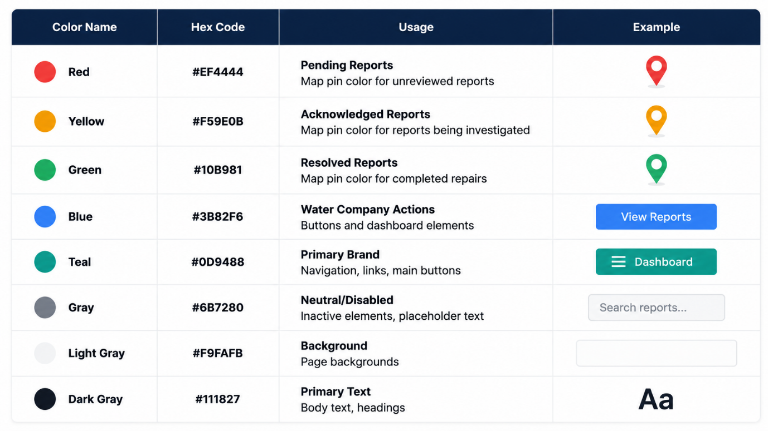
Table 3.1: Colour Scheme Reference

3.5.3 Screen Designs and Wireframes
The home page serves as the primary interface, featuring an interactive map with color-coded pins for each reported water disruption in Bamenda, accompanied by a legend explaining pin colors, filter controls for disruption type and status, a search box for tracking ID lookup, and a statistics bar showing summary counts of total, pending, acknowledged, and resolved reports.

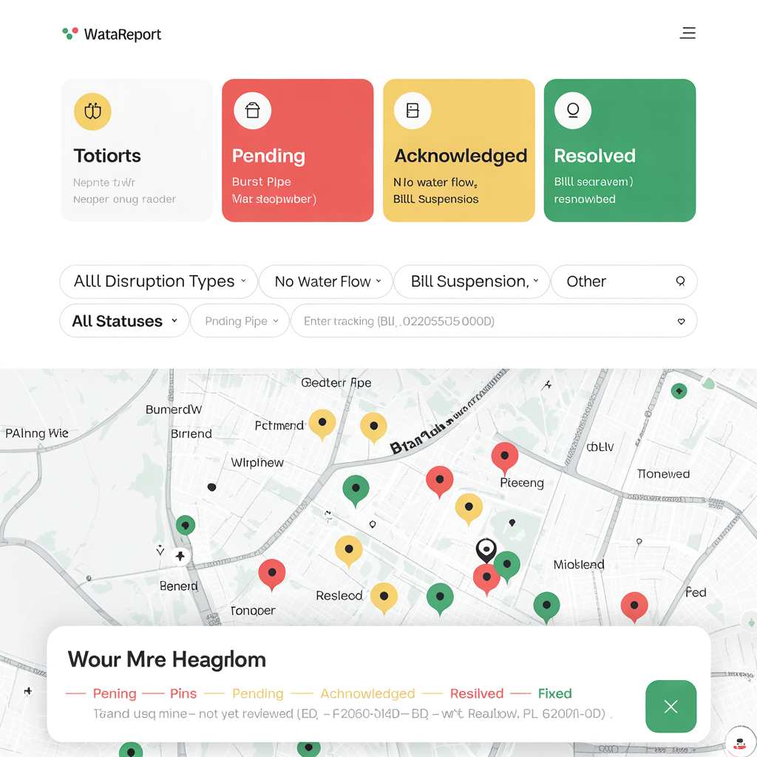
Figure 3.4: Home Page Wireframe
The report submission page is a form-based interface with automatic location capture. The form includes a disruption type dropdown with icons for each option, a textarea for description, a map showing the user's captured location with a draggable pin for manual adjustment, a file upload area for photos (up to three), an optional name field, and a submit button.

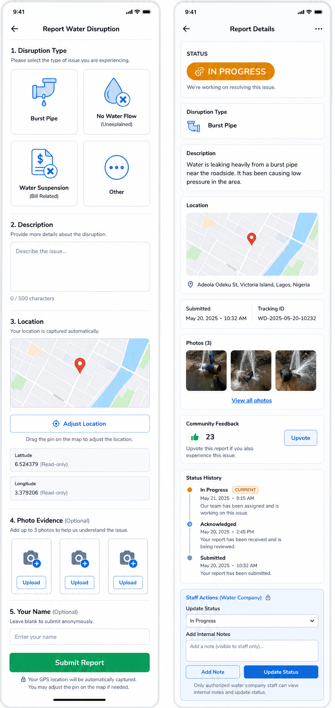
Figure 3.5: Report Submission Form Wireframe

The report detail page displays comprehensive information about a specific disruption. The page shows the report status with a large colored badge, the disruption type, description, location map with pin, submitted timestamp, tracking ID, photos gallery, upvote button with count, status history timeline, and for water company staff, action buttons to update status and add internal notes.
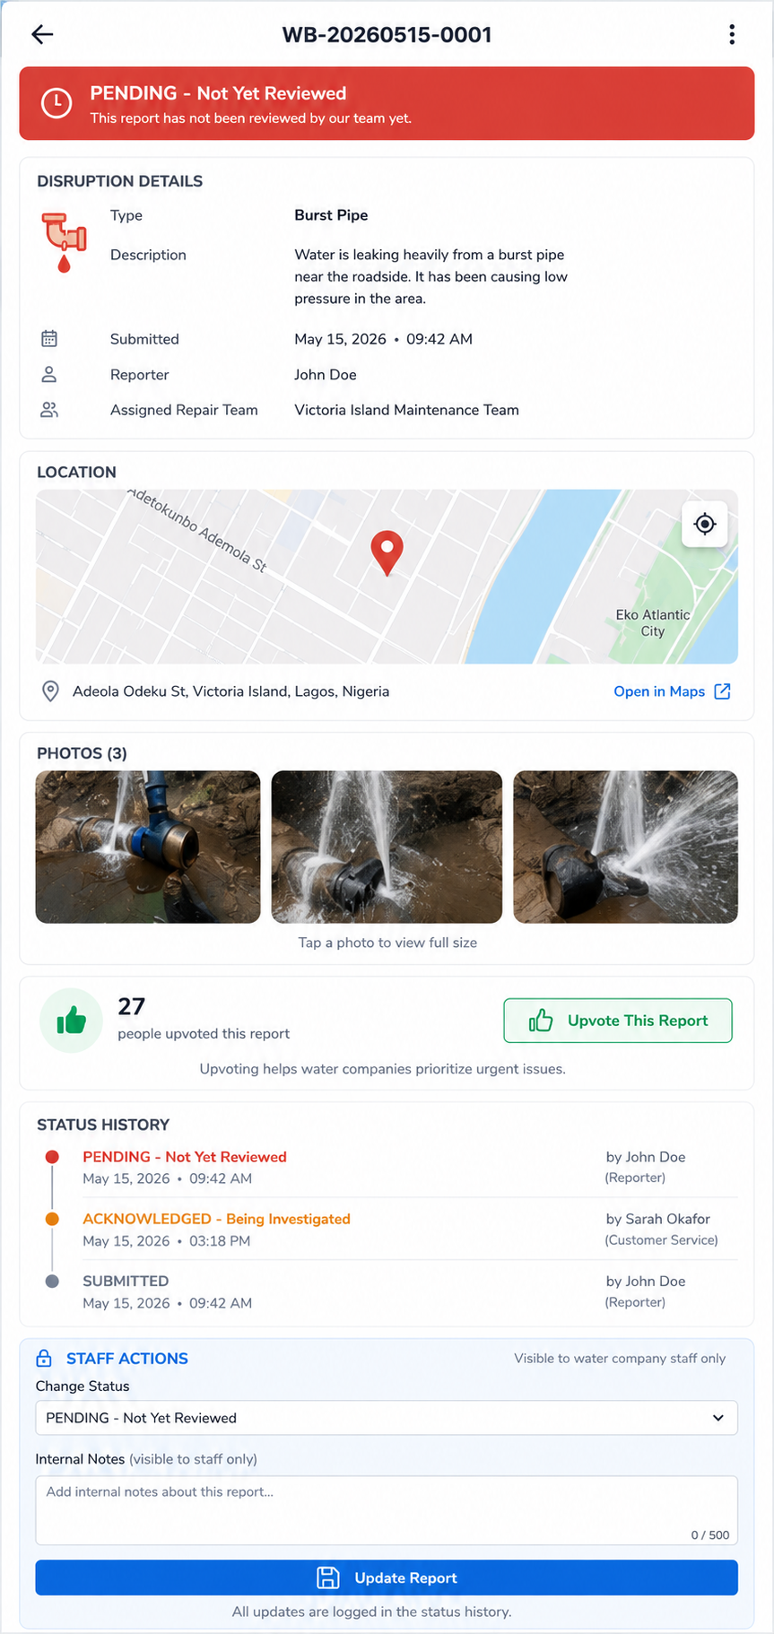
Figure 3.6: Report Detail Page Wireframe

The water company dashboard is a secure interface accessible only to authenticated water company staff. The dashboard features statistics cards, a table of all reports sorted by newest first with filtering and sorting capabilities, a map view showing all reports geographically, and action buttons for updating report status and viewing details.

3.6 Development Methodology

3.6.1 Selection of Waterfall Methodology
The project follows the Waterfall development methodology, a linear and sequential approach where each phase must be completed before the next phase begins. Waterfall was selected over Agile because the requirements for this project are well-defined and stable following the SRS document, the project scope is clear and limited to a bachelor's degree timeframe, the system is relatively small in scale making linear progression feasible, and the structured phase-by-phase approach provides clear milestones for academic assessment. Unlike Agile which expects changing requirements, Waterfall suits this project because the supervisor has already approved the requirements and no major changes are anticipated during implementation.

3.6.2 Phases of the Waterfall Model
The Waterfall model consists of five sequential phases. The Requirements Analysis Phase involved gathering and documenting all functional and non-functional requirements through stakeholder interviews, document analysis, and contextual inquiry as described in Section 3.2. The output of this phase was the approved SRS document.
The System Design Phase is documented in this chapter, producing the system architecture, database design, user interface design, and algorithm specifications. The output of this phase is a complete technical blueprint ready for implementation.
The Implementation Phase will involve coding the frontend, backend, and database based on the design specifications. The frontend will be implemented using HTML, CSS, JavaScript, and Leaflet.js. The backend will be implemented using PHP with the Laravel framework. The database will be implemented using MySQL. The output of this phase is a functioning web application.
The Testing Phase will involve unit testing of individual components, integration testing of API endpoints, system testing of the complete application, and user acceptance testing with sample stakeholders. Each test will be documented with pass/fail results. The output of this phase is a validated system ready for deployment.
The Deployment Phase will involve deploying the application to a web hosting server, configuring the production environment, and creating user documentation. The output of this phase is a live system accessible to intended users.
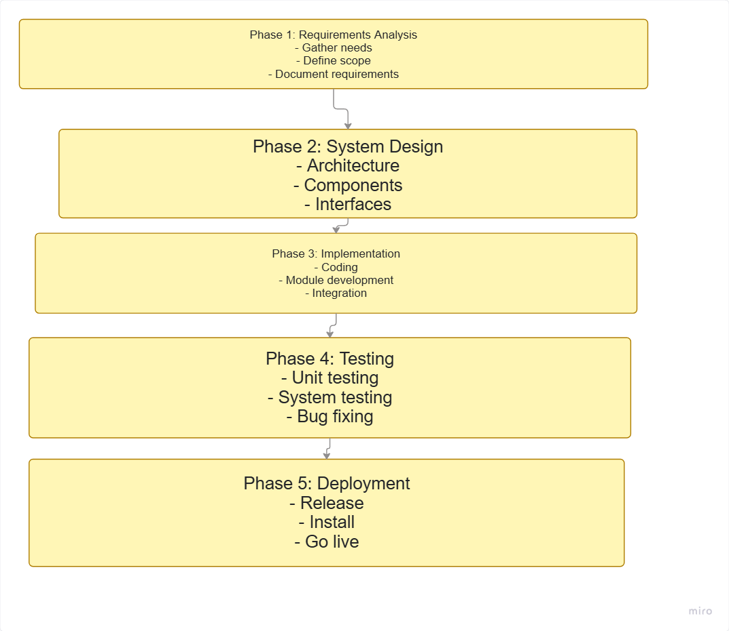
Figure 3.10: Waterfall Model Diagram

3.8 Development Tools and Environment

3.8.1 Hardware Environment
Development was conducted on a laptop computer with an Intel Core i5 processor, sixteen gigabytes of RAM, and a five hundred twelve gigabyte solid-state drive. This configuration provided sufficient performance for running the local development server, database, and frontend simultaneously. Testing was performed on physical mobile devices including an Android smartphone with a six point one inch screen and an iPhone with a five point eight inch screen to verify responsive behavior, location capture, and touch interactions.

3.8.2 Software Development Tools
The development environment was configured to match production using Windows 11 as the operating system (or Ubuntu 22.04 if preferred), XAMPP 8.2.x as the local web server environment providing Apache 2.4, PHP 8.1, and MySQL 8.0, and phpMyAdmin for graphical database management. Version control was managed through Git with a private GitHub repository, organized with a main branch for stable code and feature branches created for each major component (e.g., feature-map, feature-report-form, feature-dashboard) merged only after completion and basic testing. Visual Studio Code served as the integrated development environment with extensions for PHP IntelliSense, JavaScript code completion, Prettier for code formatting, and Tailwind CSS IntelliSense.

3.8.3 Technology Stack Summary
The technology stack was selected based on suitability for the local context, availability of documentation, ease of deployment, and compatibility with low-cost hosting.
For the frontend, HTML5 provides semantic structure for all pages, supports accessibility features through ARIA labels, and ensures cross-browser compatibility. CSS3 enables responsive design through media queries, supports modern layouts with Flexbox and Grid, and allows custom styling for color-coded status indicators. Vanilla JavaScript ES6+ requires no build tools or compilation, works reliably on older devices, reduces bandwidth usage, and is universally supported across all modern browsers. Leaflet.js 1.9.x provides open-source interactive mapping with OpenStreetMap integration, is lightweight compared to Google Maps API, and works offline with cached tiles. Chart.js 4.4.x enables simple dashboard chart implementation with vanilla JavaScript, is lightweight compared to alternatives, and provides responsive, accessible charts. Tailwind CSS 3.4.x uses a utility-first approach that accelerates development, enables responsive design without custom CSS, and purges unused styles for small production bundles.
For the backend, PHP 8.1 is widely supported on low-cost hosting platforms, has excellent documentation, integrates seamlessly with MySQL through PDO, and runs on XAMPP without additional configuration. The Laravel framework (optional or use pure PHP with PDO) provides Eloquent ORM for secure database interactions, built-in authentication, validation rules, and middleware for security. If Laravel is too heavy, a lightweight custom PHP router with PDO will be used instead.
For the database, MySQL 8.0 is a reliable open-source RDBMS with ACID compliance, supports foreign key constraints for referential integrity, has strong performance for read-heavy workloads typical of web applications, and integrates seamlessly with PHP.
For development tools, XAMPP provides a complete local web server environment with Apache, MySQL, PHP, and phpMyAdmin in a single package, simplifying development setup. Git 2.40+ enables change tracking, allows branching for feature development, provides backup through remote repositories, and supports collaboration. Visual Studio Code 1.85+ is a lightweight yet powerful editor with extensive extension ecosystem, built-in terminal, Git integration, and excellent PHP/JavaScript support.

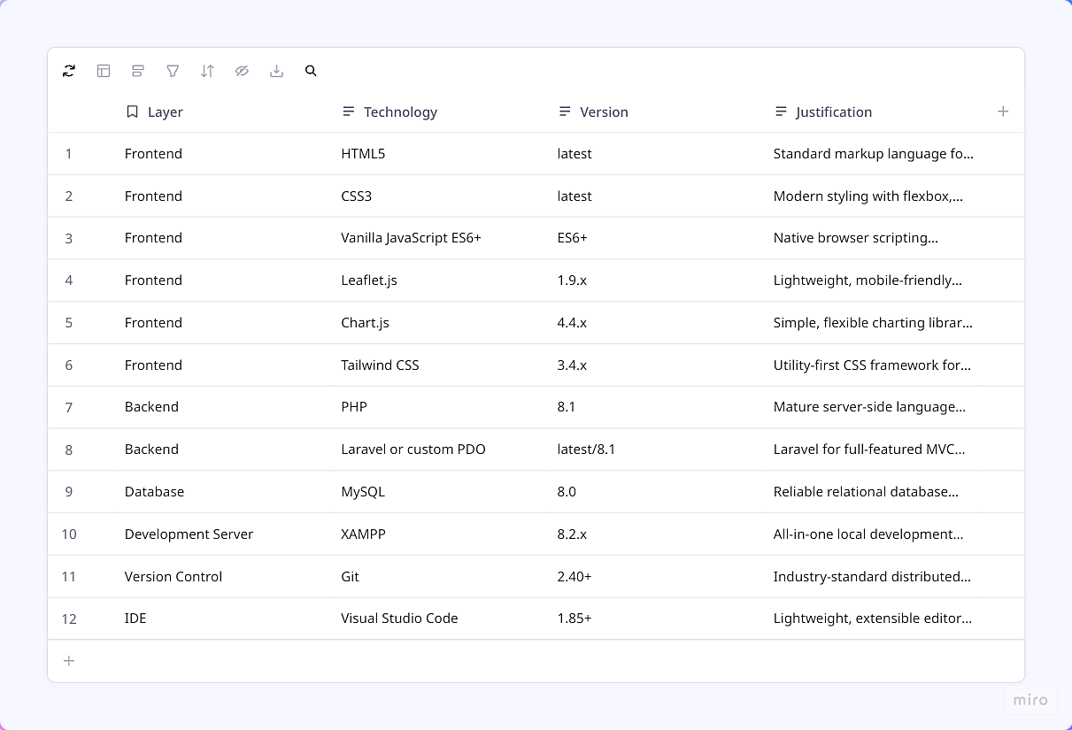
Table 3.2: Complete Technology Stack

3.9 Testing Strategy

3.9.1 Unit Testing
Unit testing verifies that individual components of the system function correctly in isolation. Each backend function will be tested with expected inputs and edge cases. The report submission function will be tested with valid data, missing required fields, and invalid GPS coordinates to ensure proper validation and error handling. The upvote function will be tested to ensure the same session ID cannot upvote the same report twice. The status update function will be tested to ensure only authenticated water company staff can change report status. The location capture function will be tested to ensure GPS coordinates are correctly captured and stored when permission is granted, and that manual address entry works when permission is denied.

3.9.2 Integration Testing
Integration testing verifies that different components of the system work together correctly. The API endpoints will be tested using Postman to ensure they return expected JSON responses with correct HTTP status codes (200 for success, 400 for bad requests, 401 for unauthorized, 404 for not found). The database integration will be tested to ensure that submitted reports are correctly inserted into the reports table with foreign key constraints enforced. The map integration will be tested to ensure that report markers load correctly from API data and that clicking a marker displays the correct report details popup.

3.9.3 System Testing
System testing verifies the complete application against the functional and non-functional requirements. Performance testing will measure page load time on a simulated 3G connection using Chrome DevTools, aiming for under three seconds. Mobile responsiveness will be tested on physical Android and iOS devices to ensure the interface adapts correctly to screen sizes from 320px to 1920px. Cross-browser compatibility will be tested on Chrome, Firefox, and Safari to ensure consistent behavior and appearance.

3.9.4 User Acceptance Testing
User acceptance testing will be conducted with a small group of stakeholders, including three community members and two water company staff. Test users will be asked to perform common tasks: submit a report, upload a photo, upvote an existing report, check report status using tracking ID, and (for water company staff) log in to the dashboard and update a report status. Feedback will be collected on ease of use, clarity of instructions, and overall satisfaction. Issues identified will be documented and fixed before final deployment.
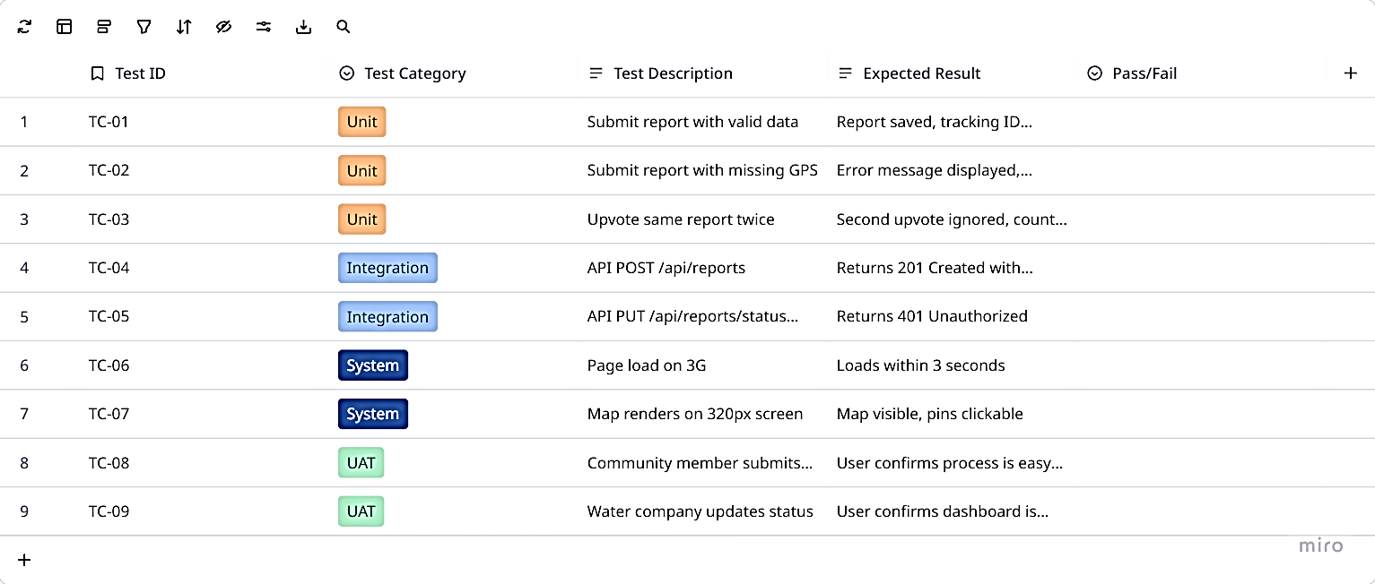
Table 3.3: Test Cases Summary

3.10 Ethical Considerations

3.10.1 Data Privacy and Protection
Several ethical considerations guide the design and operation of the system to protect user privacy and ensure responsible data handling. Community report submissions allow anonymity because the reporter name field is optional, encouraging participation from residents who may be concerned about identification or reprisal for reporting water service problems. User accounts for water company staff store minimal personal information including only username and hashed password, reducing the potential harm of any data breach. No sensitive personal data is collected from community reporters; only GPS coordinates of the reported disruption location, which is public infrastructure information, and optional name and photo are stored. Users can request deletion of their account and associated data at any time through the administrator, and such requests will be fulfilled within seven days.

3.10.2 Informed Consent
Informed consent is obtained through a consent statement presented on the report submission page. This statement explains in clear, non-technical language that the submitted report including location, description, and optional photos will be visible to water company staff and may be displayed on the public map, that the reporter's name is optional and can be left blank to remain anonymous, and that by clicking submit, the user agrees to these terms. For water company staff registering for dashboard access, a separate consent statement explains how their account information and actions (status changes, internal notes) will be logged for audit purposes.

3.10.3 Data Accuracy and Transparency
Data accuracy is promoted through clear labeling of data sources and verification processes. Community reports are clearly labeled with a "pending verification" badge until a water company staff member acknowledges them. Report status changes are visible to all users through the status history timeline, providing transparency about when and how the report was handled. The system does not automatically verify the accuracy of reported disruptions; instead, it relies on water company staff to validate reports during their response process.

3.10.4 System Use Disclaimer
A disclaimer is prominently displayed on the report submission page stating that WataReport is a reporting and tracking tool only and does not guarantee immediate response from water companies. The disclaimer explains that urgent water emergencies should still be reported through official emergency channels, and that the system is provided as a supplementary communication tool. This disclaimer protects the project from liability while managing user expectations appropriately.

3.11 System Diagrams

3.11.1 Use Case Diagram
The use case diagram identifies four external actors and their interactions with the WataReport system. Community members can view the map, view report details, submit new disruption reports, upvote existing reports, and check report status using a tracking ID. Water company staff (plumbers, bill collectors, customer service) can log in, view dashboard, view all reports on map and table, update report status (pending → acknowledged → resolved), assign repair teams, and add internal notes. Administrators have all water company staff permissions plus the ability to manage user accounts (create, edit, delete), view all reports regardless of status, and export report data to CSV. Guest users (unauthenticated) can only view the public map and view report details, but cannot submit reports or upvote.
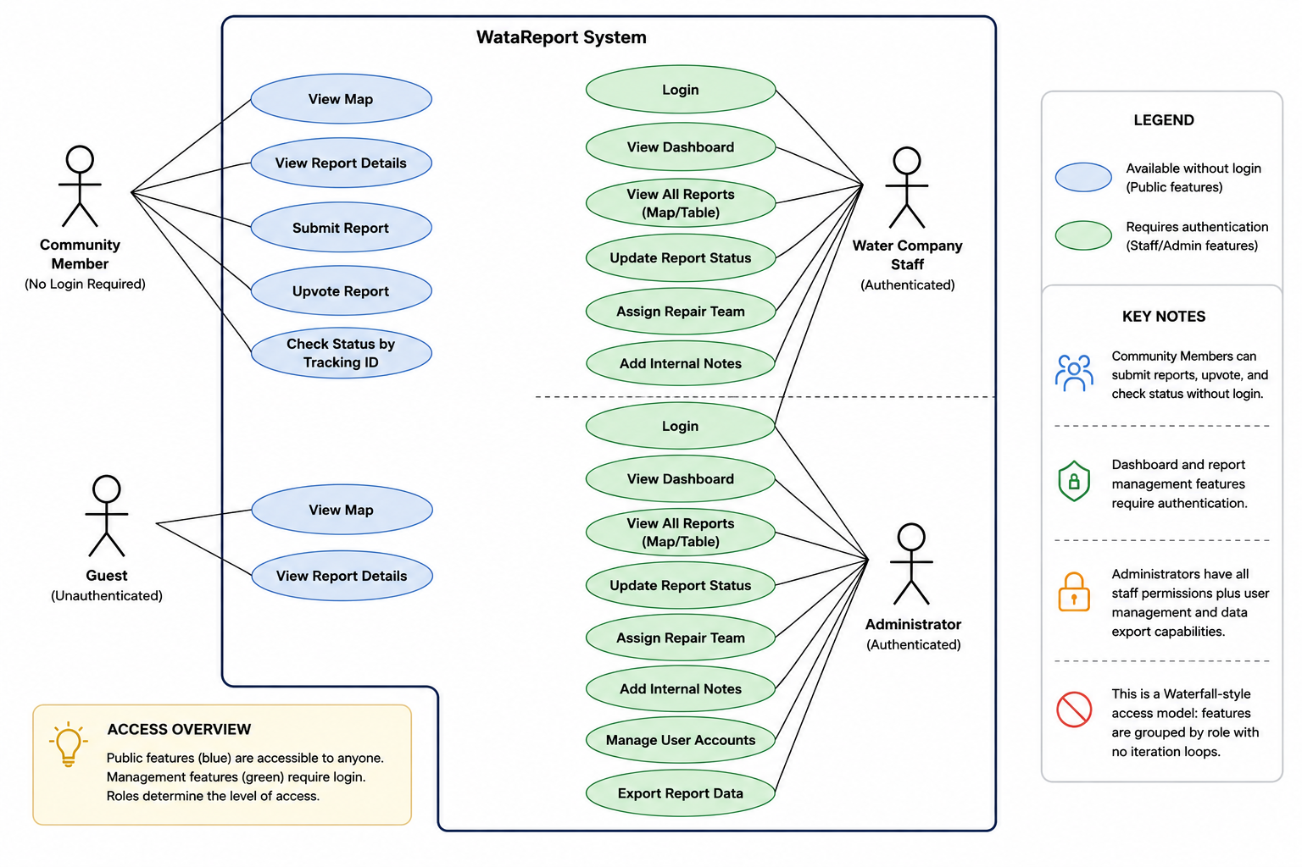
Figure 3.11: Use Case Diagram

3.11.2 Class Diagram
The class diagram represents the static structure of the system with five main classes corresponding to the database tables: User, Report, Photo, Upvote, and StatusHistory. The User class has attributes: id, username, password_hash, role, company_name, created_at, updated_at, and methods: login(), logout(), hasPermission(). The Report class has attributes: id, tracking_id, issue_type, description, latitude, longitude, address, reporter_name, upvote_count, status, created_at, acknowledged_at, resolved_at, assigned_team, internal_notes, created_by, and methods: submit(), updateStatus(), calculatePriority(), getResolutionTime(). The Photo class has attributes: id, report_id, file_path, uploaded_at, and methods: upload(), delete(). The Upvote class has attributes: id, report_id, session_id, created_at, and methods: add(), hasUserUpvoted(). The StatusHistory class has attributes: id, report_id, user_id, old_status, new_status, created_at, and methods: logChange(), getHistoryForReport().
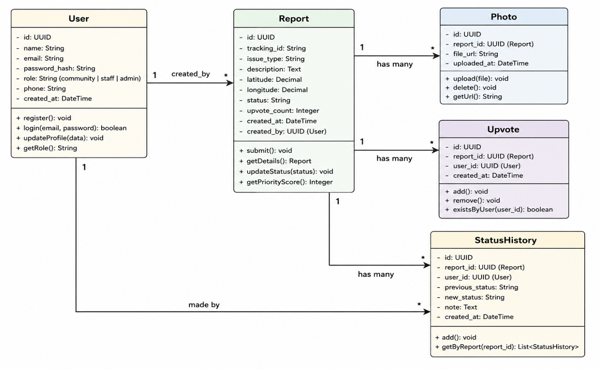
Figure 3.12: Class Diagram

3.11.3 Entity Relationship Diagram
The entity relationship diagram provides a database-level view showing tables as entities, columns as attributes, and foreign key relationships as connections using crow's foot notation. The diagram illustrates that photos, upvotes, and status_history all reference reports through foreign keys, and reports references users through the created_by foreign key.
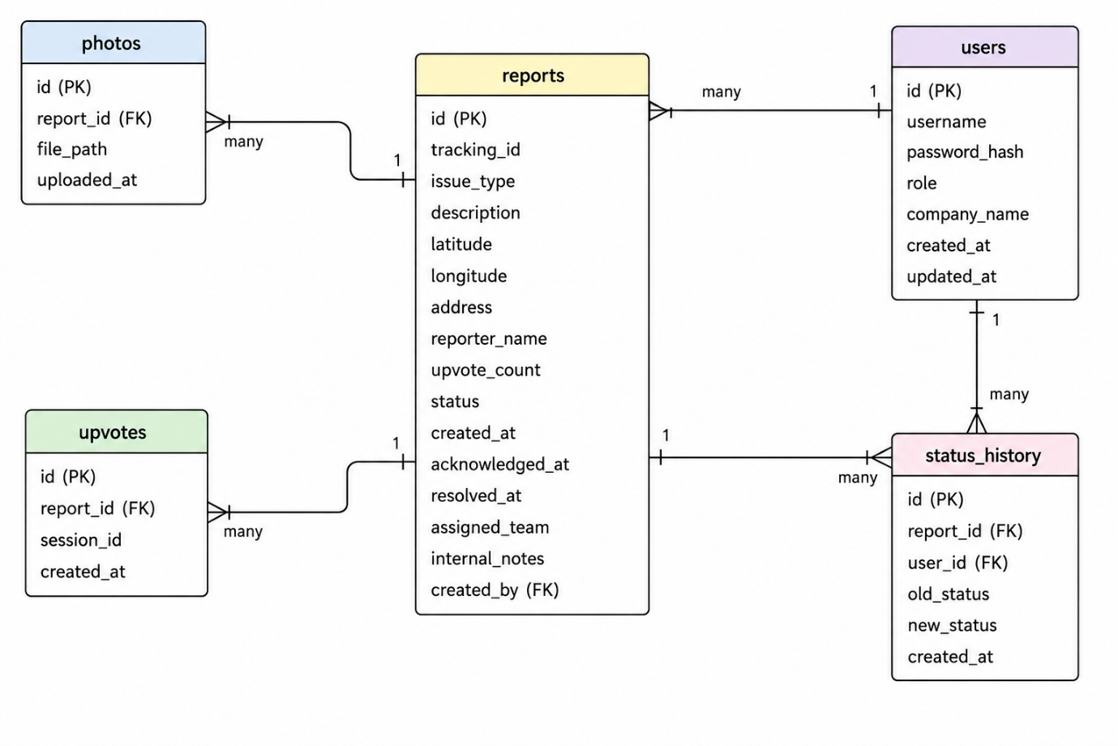
Figure 3.13: Entity Relationship Diagram

3.11.4 Activity Diagram (Report Submission Flow)
The activity diagram illustrates the sequence of activities when a community member submits a water disruption report. The flow begins with the user accessing the report form, then entering disruption details, capturing location, optionally adding photos, submitting the form, and receiving a tracking ID.

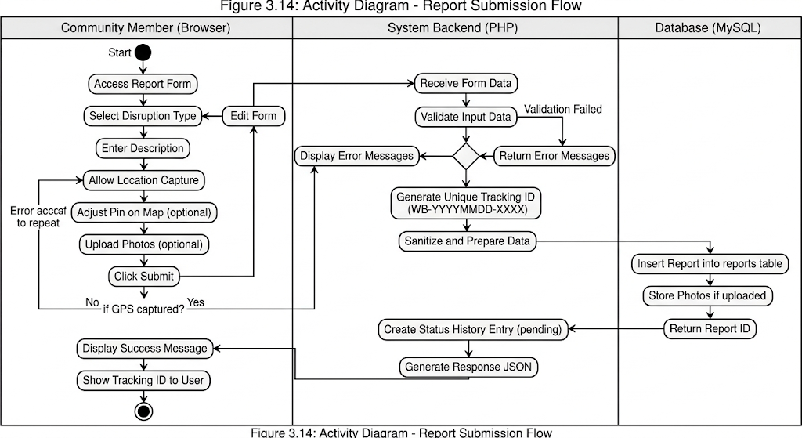
Figure 3.14: Activity Diagram - Report Submission Flow

3.11.5 Sequence Diagram (Report Status Update)
The sequence diagram illustrates the interaction between components when a water company staff member updates a report status from pending to acknowledged.
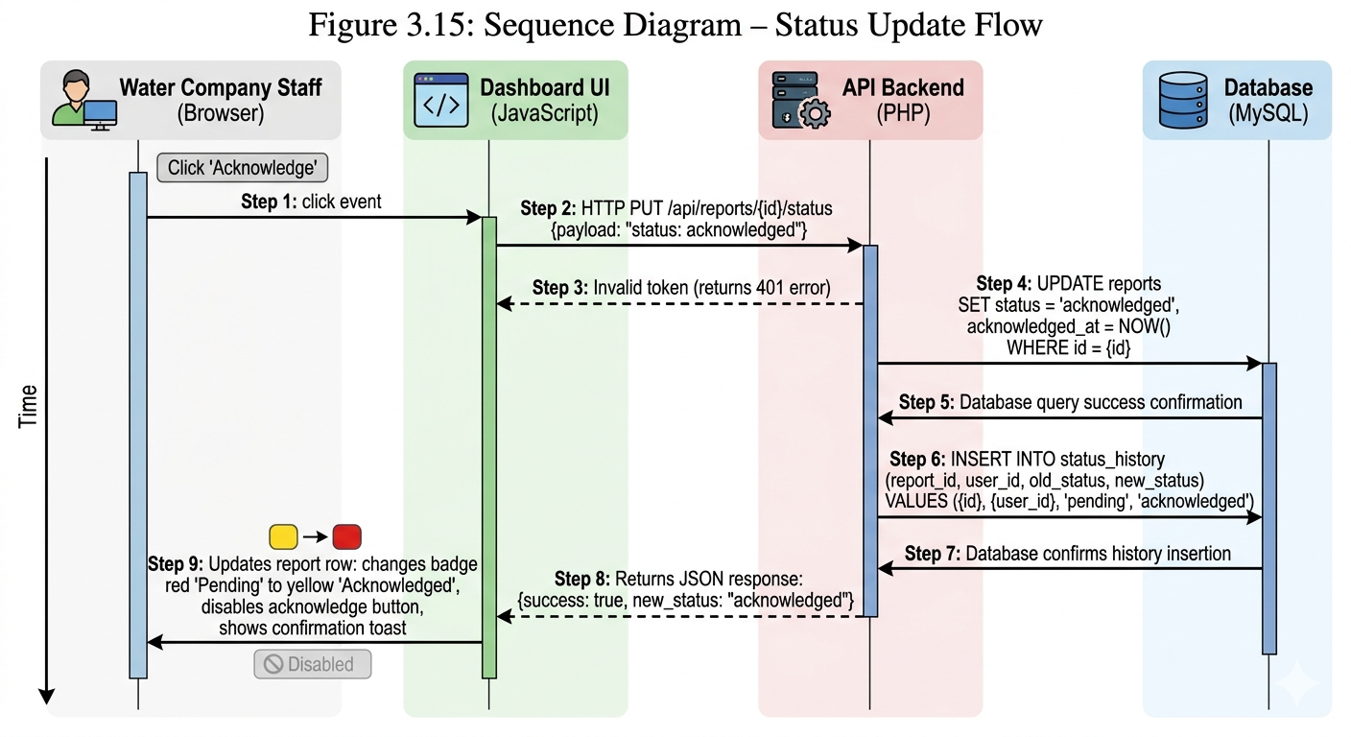
Figure 3.15: Sequence Diagram - Status Update Flow

3.12 Summary
This chapter has presented the complete research methodology and system design for WataReport – Community Water Service Disruption Reporting System for Bamenda, Cameroon. The study adopts a design science research methodology, which is appropriate for creating and evaluating a technological artifact to solve a real-world problem. Requirements were gathered through document analysis, stakeholder analysis, and contextual inquiry, resulting in a comprehensive set of functional and non-functional requirements.
The system follows a three-tier architecture with an HTML/CSS/JavaScript frontend (presentation tier), a PHP/Laravel backend (application tier), and a MySQL database (data tier). The database design includes five main tables supporting reports, users, photos, upvotes, and status history, with careful attention to relationships, indexing, and audit tracking.
The user interface design follows mobile-first principles with color-coded map pins for intuitive communication of report status (red for pending, yellow for acknowledged, green for resolved). Wireframes for the home page, report form, report detail page, and water company dashboard provide a visual blueprint for implementation. Processing logic includes a report prioritization algorithm and resolution time tracking algorithm.
The development methodology is Waterfall with five sequential phases: requirements analysis, system design (this chapter), implementation, testing, and deployment. The technology stack is clearly defined with specific versions and justifications. The testing strategy covers unit, integration, system, and user acceptance levels with defined test cases.
Ethical considerations address data privacy and anonymity, informed consent, data accuracy and transparency, and appropriate disclaimers. System diagrams including use case, class, entity relationship, activity, and sequence diagrams provide complete visual documentation of the system design.
The next chapter (Chapter Four) will present the implementation of the system based on the design specifications documented in this chapter.

References
Akinyemi, T. O., & Adebayo, A. A. (2022). Community-based reporting of water infrastructure faults in Lagos, Nigeria. Journal of Water, Sanitation and Hygiene for Development, 12(3), 245-258.
Chambers, R. (2018). Can we know better? Reflections on development. Practical Action Publishing.
Cornwall, A., & Gaventa, J. (2021). Bridging the gap: Citizen participation and water service accountability. Community Development Journal, 56(2), 178-195.
Ewane, E. B., & Fonyuy, C. A. (2023). Customer communication challenges in water utilities of Cameroon's North West Region. Cameroon Journal of Environmental Management, 8(1), 45-59.
Fombu, A. N., & Ndeh, S. T. (2023). A review of digital citizen reporting platforms in Cameroon: Successes and failures. African ICT Research, 14(2), 88-102.
Goodchild, M. F. (2018). Citizens as sensors: The world of volunteered geography. GeoJournal, 69(4), 211-221.
Johnson, P., & Martinez, L. (2021). SeeClickFix and the future of civic technology. Urban Affairs Review, 57(3), 412-435.
Mbaku, J. M. (2023). Water service suspension and customer rights in Cameroon. African Public Policy Review, 11(2), 67-82.
Mbah, P. N., & Ndum, B. A. (2022). Challenges faced by plumbers in responding to burst pipe reports in Bamenda. Cameroon Journal of Infrastructure Studies, 5(1), 34-48.
Mwangi, J. K., & Karanja, D. M. (2022). Map-based water fault reporting: A case study of Nairobi City Water and Sewerage Company. East African Journal of Engineering, 9(3), 156-170.
Nformi, B. T., & Che, V. C. (2023). GPS accuracy and usability for citizen reporting in Cameroon's urban centers. Journal of Geospatial Science in Africa, 7(2), 89-104.

